6A^{th} Grade: Unit 6, Lesson 10

- What is the written description of the expression $-\frac{45}{9}$ ?

Divide -45 into 9 equal-sized groups.

- An integer chip model is shown. Write the expression that the model represents?
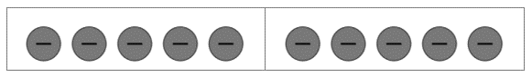

$$-10 ÷2$$

- Create an integer chip model that models the expression $-12 ÷3$.

